FitBuddy-AI — AI-Powered Personalized Workout & Nutrition Planner
Project Design Phase-II
Data Flow Diagram & User Stories
Date | 22/09/2026
Team ID | SWTID-2026-9413
Team Size | 4
Project Name | FitBuddy-AI
Team Leader: Praveenkumar J | Team Members: Praveen, PremAnand R, Susibala A

Data Flow Diagram
A Data Flow Diagram (DFD) is a visual representation of the information flow within a system. It shows how data enters and leaves the system, what transforms it, and where it is stored. The diagram below traces a request from the client through validation and the AI service layer down to the SQLite database, and back out as a rendered page or JSON response.
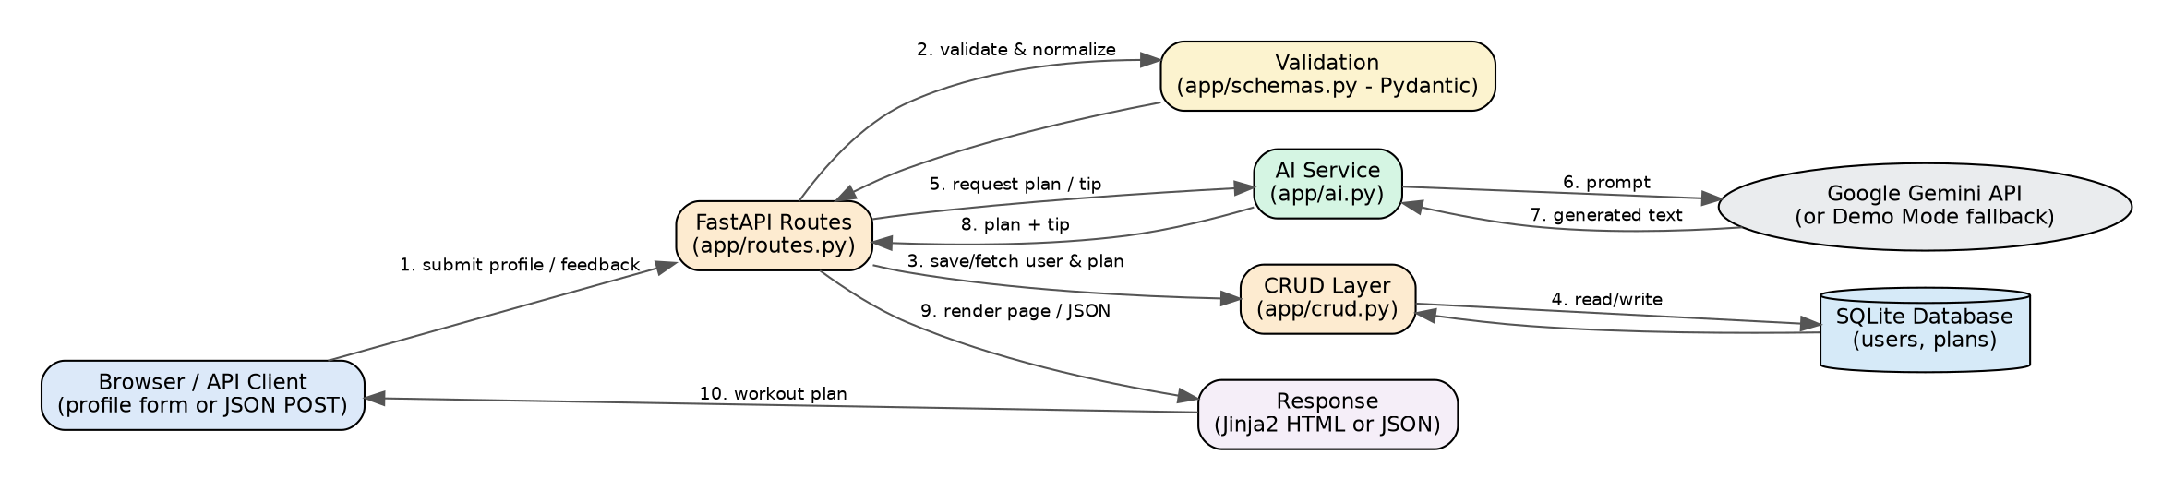

User Stories
User Type | Story # | User Story / Task | Acceptance Criteria | Priority | Release
Visitor | USN-1 | As a user, I can submit my profile (name, user ID, age, weight, goal, intensity) through a simple form | A valid submission creates or updates a user record and moves to the plan page | High | Sprint-1
Visitor | USN-2 | As a user, I can receive an AI-generated 7-day workout plan based on my profile | Gemini (or demo mode) returns a Day 1–Day 7 plan shown on the workout page | High | Sprint-1
Visitor | USN-3 | As a user, I can receive a nutrition tip tailored to my stated goal | A short, goal-specific tip is generated and shown alongside the plan | High | Sprint-1
Visitor | USN-4 | As a user, I can submit feedback on my plan and get an updated plan | Submitting feedback stores it and returns a revised plan that reflects it | Medium | Sprint-2
Developer | USN-5 | As a developer, I can call JSON REST endpoints to create plans and fetch a user's plan | /api/workouts and /api/users/{user_id} return correct JSON with proper status codes | Medium | Sprint-2
Administrator | USN-6 | As an admin, I can view every registered user and delete one from a dashboard | /view-all-users lists all users; delete removes the user and their plans | Medium | Sprint-2

